SHANTANU JOSHI J073

IOT ASSIGNMENT 2

1.

void setup()

{

pinMode(7, OUTPUT);

pinMode(8, OUTPUT);

pinMode(6, OUTPUT);

pinMode(5, OUTPUT);

}

void loop()

{

digitalWrite(7, HIGH);

delay(3000);

tone(8,440);

delay(2000);

digitalWrite(7, LOW);

noTone(8);

digitalWrite(6,HIGH);

delay(500);

digitalWrite(6,LOW);

delay(500);

digitalWrite(6,HIGH);

delay(500);

digitalWrite(6,LOW);

delay(500);

digitalWrite(6,HIGH);

delay(500);

digitalWrite(6,LOW);

delay(500);

digitalWrite(6,HIGH);

delay(500);

digitalWrite(6,LOW);

delay(500);

digitalWrite(6,HIGH);

delay(500);

digitalWrite(6,LOW);

delay(500);

digitalWrite(5, HIGH);

delay(3000);

tone(8,440);

delay(2000);

digitalWrite(5, LOW);

noTone(8);

}

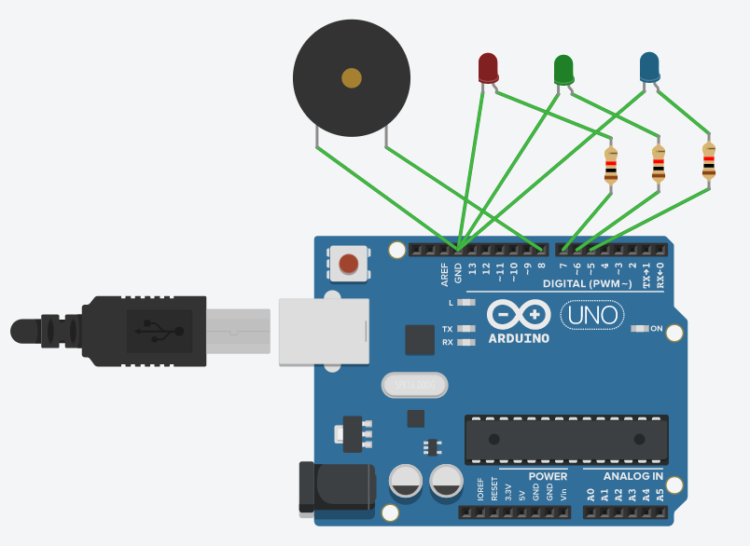

2.

void setup()

{

pinMode(7, OUTPUT);

pinMode(A0, INPUT);

Serial.begin(9600);

}

void loop()

{

int read=analogRead(A0);

Serial.println(read);

tone(7,read);

}

